Header text goes here (single line only)

Normal text goes here, should fit in this box (Times New Roman 12pt). Leave some space for a small picture (eg. a logo) if required.

Specify any hyperlinks / URLs here:

All photo material is welcome. Not that accompanying photos/images for left side of the webpage should be 640 pixels high x 320 pixels wide (or a 640x320 crop / cut out of the picture should be possible). Please send your contribution to h.gosker@maastrichtuniversity.nl

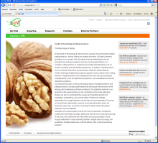
picture for left
colom 640x320 pixels
main text,
use template

